Western Student Connections  Suite 2, 46 Bultje Street  Dubbo NSW 2830  Phone: 02 6885 6144  Fax: 02 6885 6199  Email: reception@wsc.edu.au  Web: www.wsc.edu.au  ABN: 2618 9442 391 | 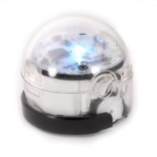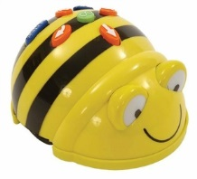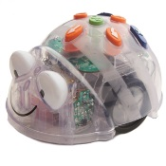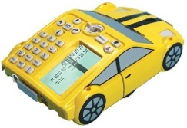 | 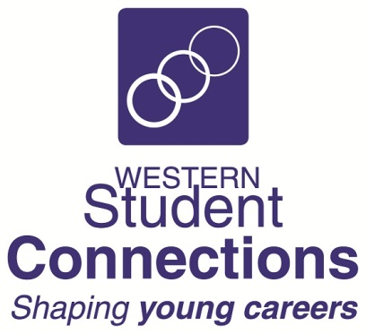
STEAM – Science, Technology, Engineering, Arts, Mathematics
Bee-bot, Blue-bot, Pro-bot and Ozobot Robotics

Booking Sheet 2018

Fax back to: 02 6885 6199 or Email to: reception@wsc.edu.au

School Name:
School STEM Contact:
Contact Email Address:

Robotics Workshops:

Year Group (s) |  |  | No of students:
Workshop type: | Beginner Basics |  |  | Intermediate |  |  | Advanced
Robots: | Bee-bot & Blue-bot |  |  |  | Pro-bot |  | Ozobot
Preferred dates: | Term: |  | Week: |  |  | Date: |  | / |  | / 2018
Preferred dates: | Term: |  | Week: |  |  | Date: |  | / |  | / 2018
Preferred dates: | Term: |  | Week: |  |  | Date: |  | / |  | / 2018
Preferred dates: | Term: |  | Week: |  |  | Date: |  | / |  | / 2018

You will receive an email to confirm your booking.

Regards

Ana Pateman
Chief Executive Officer
Western Student Connections

